**EXPERIMENT NO 1**

Name: Ronika Paul

Roll No:30

Batch: MCA B

Date: 25/03/2022

**AIM**

To study various DDL commands - CREATE

**QUESTION**

Create the following Tables

**Table 1: DEPOSIT**

ACTNO VARCHAR2(5) PRIMARY KEY, FIRST LETTER MUST START WITH ‘D’ CNAME VARCHAR2(15) FOREIGN KEY REFERENCES CUSTOMER

BNAME VARCHAR2(20) FOREIGN KEY REFERENCES BRANCH AMOUNT NUMBER (8,2) NOT NULL, CANNOT BE 0

ADATE DATE

**Table 2: BRANCH**

BNAME VARCHAR2(20) PRIMARY KEY

CITY VARCHAR2(30) NOT NULL , any one of NAGPUR, DELHI, BANGALORE, BOMBAY

**Table 3: CUSTOMER**

CNAME VARCHAR2(15) PRIMARY KEY CITY VARCHAR2(20) NOT NULL ,

**Table 4: BORROW**

LOANNO VARCHAR2(8) PRIMARY KEY / FIRST LETTER MUST START WITH ‘L’ CNAME VARCHAR2(15) FOREIGN KEY REFERENCES CUSTOMER

BNAME VARCHAR2(20) FOREIGN KEY REFERENCES BRANCH AMOUNT NUMBER(8,2) NOT NULL, CANNOT BE 0

**PROCEDURE**

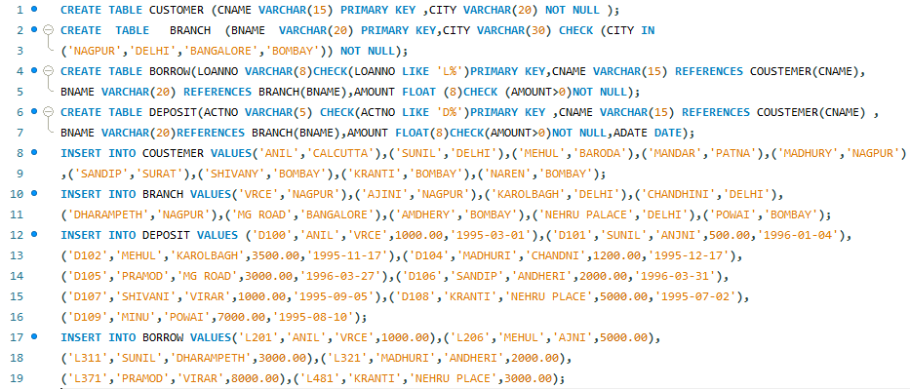

**OUTPUT**

1.DEPOSIT

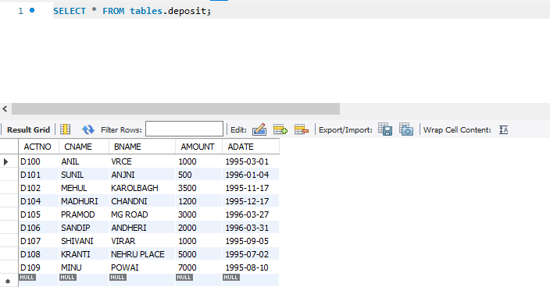

2.BRANCH

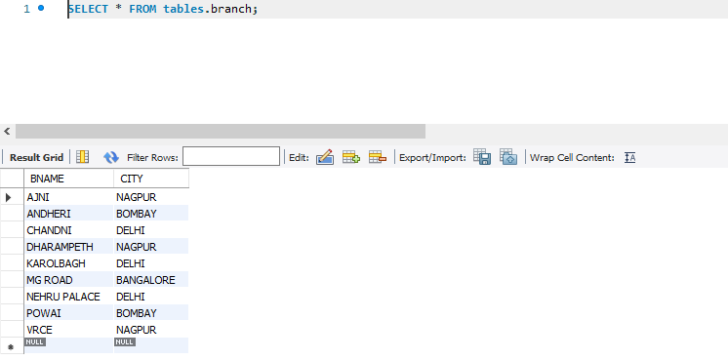

3.CUSTOMER

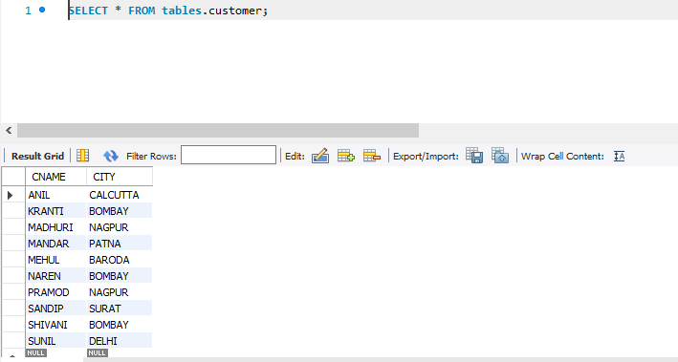

4.BORROW

